
Third Sunday in Lent
Bethlehem Lutheran Church
March 8, 2026
Sunday 10:00 a.m.

- Welcome to All! We are glad that you are able to worship with us today. Please fill out a connection card in the pews if you like. During the service, we will sit or stand in reverence to our Lord. Please do what is physically comfortable and reverent for you. For those who are unable to receive Communion near the altar and wish to have the Pastor administer it at your seat, please obtain a red and white card from one of the ushers and hold it up at Communion time to alert the Pastor. If you or a little one would like to receive a blessing instead of Holy Communion, we invite you to come forward and cross your arms at the time of Communion. Please feel free to introduce yourself to our Pastor and fill in your name, address, etc in the guest book near the entrance to the sanctuary.

Evangelical Lutheran Worship – Setting 3, page 138

Pre-Worship Music/Announcements

Prelude

GATHERING

Confession and Forgiveness

P: Blessed be the holy Trinity, ☩ one God, who forgives all our sin, whose mercy endures forever.
C: Amen.

P: Let us confess our sin before God, who removes our guilt and blots out all offenses.

Silence is kept for reflection.

P: Gracious God,
C: have mercy on us according to your steadfast love.
P: For desiring self-reliance instead of hungering for your word: Gracious God,
C: have mercy on us according to your steadfast love.
P: For failing to recognize your coming reign, and for hindering the work of the Spirit: Gracious God,
C: have mercy on us according to your steadfast love.
(continued on next page)
P: For drawing from the well of self-serving ambition, and for disdaining the living water Christ offers: Gracious God,
C: have mercy on us according to your steadfast love.
P: For disregarding voices from the margin, and for distrusting signs of your healing and hope in the world: Gracious God,
C: have mercy on us according to your steadfast love.
P: For dwelling in tombs of self-pity and discontent, and for disregarding Christ’s call to come forth to life: Gracious God,
C: have mercy on us according to your steadfast love.

P: God’s steadfast love, grace, and forgiveness abound. Through faith, the free gift of God, you have been clothed in the righteousness of Christ. In the name of ☩ Jesus Christ, your sins are forgiven. The Spirit of the One who raised Christ from the dead dwells in you, pours God’s love into your hearts, and gives you life and peace.
C: Amen.

Gathering Hymn Open Now Thy Gates of Beauty ELW 533
Greeting

A: The grace of our Lord Jesus Christ, the love of God, and the communion of the Holy Spirit be with you all. C: And also with you.

Kyrie (lead by Pastor Paul)

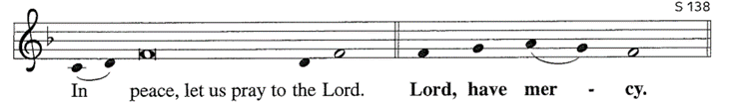
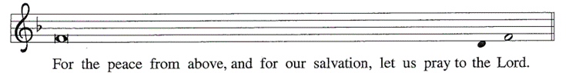
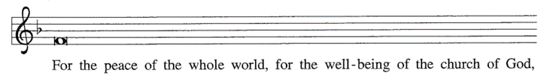

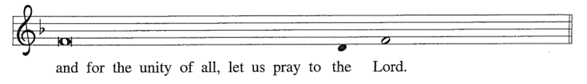

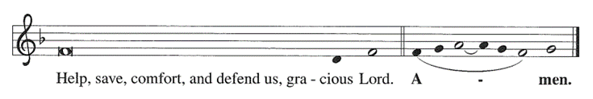
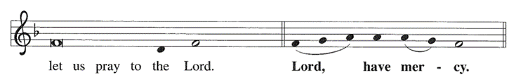
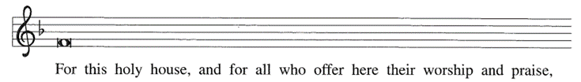
Hymn of Praise Glory to God

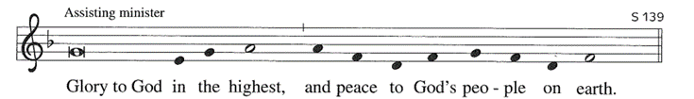
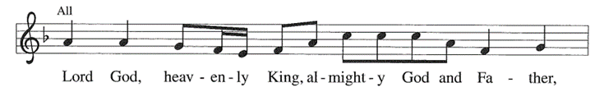
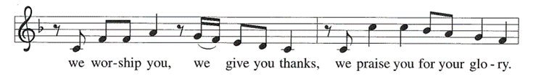
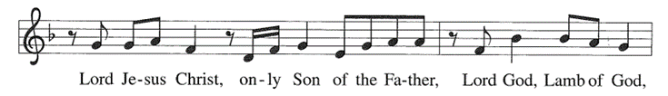
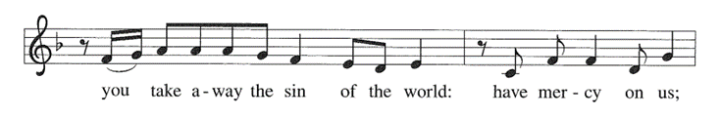
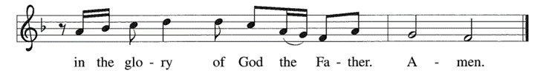
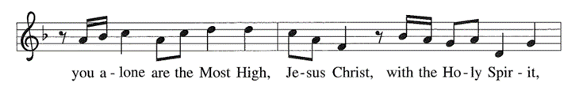
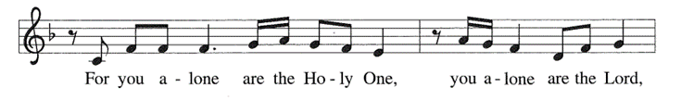
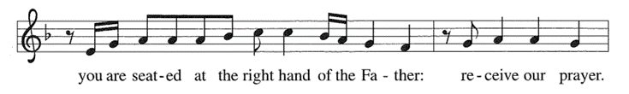

Prayer of the Day

A: The Lord be with you. C: And also with you.
A: Let us pray together… C: Merciful God, the fountain of living water, you quench our thirst and wash away our sin. Give us this water always. Bring us to drink from the well that flows with the beauty of your truth through Jesus Christ, our Savior and Lord, who lives and reigns with you and the Holy Spirit, one God, now and forever.
Amen.

WORD

First Lesson Exodus 17:1-7
Because the thirsty Israelites quarreled with Moses and put God to the test, Moses cried out in desperation to God. God commanded Moses to strike the rock to provide water for the people. The doubt-filled question—“Is the Lord among us or not?”—received a very positive answer.

1 From the wilderness of Sin the whole congregation of the Israelites journeyed by stages, as the Lord commanded. They camped at Rephidim, but there was no water for the people to drink. 2 The people quarreled with Moses and said, “Give us water to drink.” Moses said to them, “Why do you quarrel with me? Why do you test the Lord?”
(continued on next page)

3 But the people thirsted there for water, and the people complained against Moses and said, “Why did you bring us out of Egypt, to kill us and our children and livestock with thirst?” 4 So Moses cried out to the Lord, “What shall I do for this people? They are almost ready to stone me.” 5 The Lord said to Moses, “Go on ahead of the people and take some of the elders of Israel with you; take in your hand the staff with which you struck the Nile and go. 6 I will be standing there in front of you on the rock at Horeb. Strike the rock, and water will come out of it, so that the people may drink.” Moses did so, in the sight of the elders of Israel. 7 He called the place Massah and Meribah, because the Israelites quarreled and tested the Lord, saying, “Is the Lord among us or not?”

L: The Word of the Lord.
C: Thanks be to God.

Psalmody Psalm 95

1 Come, let us sing to the Lord; let us shout for joy to the rock of our salvation.
2 Let us come before God’s presence with thanksgiving and raise a loud shout to the Lord with psalms.
3 For you, Lord, are a great God, and a great ruler above all gods.
4 In your hand are the caverns of the earth; the heights of the hills are also yours.
5 The sea is yours, for you made it, and your hands have molded the dry land.
6 Come, let us worship and bow down, let us kneel before the Lord our maker.
7 For the Lord is our God, and we are the people of God’s pasture and the sheep of God’s hand. Oh, that today you would hear God’s voice!
8 “Harden not your hearts, as at Meribah, as on that day at Massah in the desert.
9 There your ancestors tested me, they put me to the test, though they had seen my works.
10 Forty years I loathed that generation, saying, ‘The heart of this people goes astray; they do not know my ways.’
11 Indeed I swore in my anger, ‘They shall never come to my rest.’ ”

Second Lesson Romans 5:1-11
Though we often hear that God helps those who help themselves, here Paul tells us that through Jesus’ death God helps utterly helpless sinners. Since we who had been enemies are reconciled to God in the cross, we now live in hope for our final salvation.

1 Since we are justified by faith, we have peace with God through our Lord Jesus Christ, 2 through whom we have obtained access to this grace in which we stand, and we boast in our hope of sharing the glory of God.
(continued on next page)
3 And not only that, but we also boast in our afflictions, knowing that affliction produces endurance, 4 and endurance produces character, and character produces hope, 5 and hope does not put us to shame, because God’s love has been poured into our hearts through the Holy Spirit that has been given to us. 6 For while we were still weak, at the right time Christ died for the ungodly. 7 Indeed, rarely will anyone die for a righteous person—though perhaps for a good person someone might actually dare to die. 8 But God proves his love for us in that while we still were sinners Christ died for us. 9 Much more surely, therefore, since we have now been justified by his blood, will we be saved through him from the wrath of God. 10 For if while we were enemies we were reconciled to God through the death of his Son, much more surely, having been reconciled, will we be saved by his life. 11 But more than that, we even boast in God through our Lord Jesus Christ, through whom we have now received reconciliation.

L: The Word of the Lord.
C: Thanks be to God.

Gospel Acclamation Return to the Lord
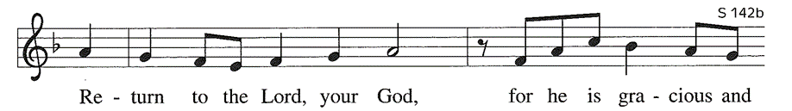
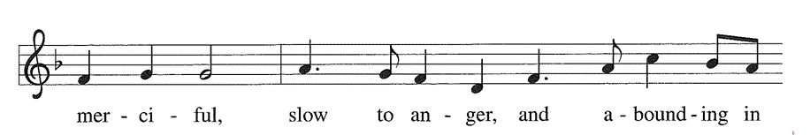
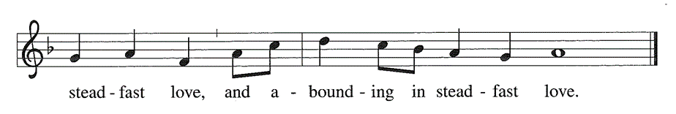

Gospel John 4:5-42

Jesus defies convention to engage a Samaritan woman in conversation. Her testimony, in turn, leads many others to faith.

C: …Glory to you, O Lord…

5 Jesus came to a Samaritan city called Sychar, near the plot of ground that Jacob had given to his son Joseph.6 Jacob’s well was there, and Jesus, tired out by his journey, was sitting by the well. It was about noon. 7 A Samaritan woman came to draw water, and Jesus said to her, “Give me a drink.” 8 (His disciples had gone to the city to buy food.) (continued on next page)
9 The Samaritan woman said to him, “How is it that you, a Jew, ask a drink of me, a woman of Samaria?” (Jews do not share things in common with Samaritans.) 10 Jesus answered her, “If you knew the gift of God and who it is that is saying to you, ‘Give me a drink,’ you would have asked him, and he would have given you living water.” 11 The woman said to him, “Sir, you have no bucket, and the well is deep. Where do you get that living water? 12 Are you greater than our ancestor Jacob, who gave us the well and with his sons and his flocks drank from it?” 13 Jesus said to her, “Everyone who drinks of this water will be thirsty again, 14 but those who drink of the water that I will give them will never be thirsty. The water that I will give will become in them a spring of water gushing up to eternal life.” 15 The woman said to him, “Sir, give me this water, so that I may never be thirsty or have to keep coming here to draw water.” 16 Jesus said to her, “Go, call your husband, and come back.” 17 The woman answered him, “I have no husband.” Jesus said to her, “You are right in saying, ‘I have no husband,’ 18 for you have had five husbands, and the one you have now is not your husband. What you have said is true!” 19 The woman said to him, “Sir, I see that you are a prophet. 20 Our ancestors worshiped on this mountain, but you say that the place where people must worship is in Jerusalem.” 21 Jesus said to her, “Woman, believe me, the hour is coming when you will worship the Father neither on this mountain nor in Jerusalem. 22 You worship what you do not know; we worship what we know, for salvation is from the Jews. 23 But the hour is coming and is now here when the true worshipers will worship the Father in spirit and truth, for the Father seeks such as these to worship him. 24 God is spirit, and those who worship him must worship in spirit and truth.” 25 The woman said to him, “I know that Messiah is coming” (who is called Christ). “When he comes, he will proclaim all things to us.” 26 Jesus said to her, “I am he, the one who is speaking to you.” 27 Just then his disciples came. They were astonished that he was speaking with a woman, but no one said, “What do you want?” or, “Why are you speaking with her?” 28 Then the woman left her water jar and went back to the city. She said to the people, 29 “Come and see a man who told me everything I have ever done! He cannot be the Messiah, can he?” 30 They left the city and were on their way to him. 31 Meanwhile the disciples were urging him, “Rabbi, eat something.” 32 But he said to them, “I have food to eat that you do not know about.” 33 So the disciples said to one another, “Surely no one has brought him something to eat?” 34 Jesus said to them, “My food is to do the will of him who sent me and to complete his work. 35 Do you not say, ‘Four months more, then comes the harvest’? But I tell you, look around you, and see how the fields are ripe for harvesting. 36 The reaper is already receiving wages and is gathering fruit for eternal life, so that sower and reaper may rejoice together. 37 For here the saying holds true, ‘One sows and another reaps.’ 38 I sent you to reap that for which you did not labor. Others have labored, and you have entered into their labor.” 39 Many Samaritans from that city believed in him because of the woman’s testimony, “He told me everything I have ever done.” 40 So when the Samaritans came to him, they asked him to stay with them, and he stayed there two days. 41 And many more believed because of his word.

(continued on next page)
42 They said to the woman, “It is no longer because of what you said that we believe, for we have heard for ourselves, and we know that this is truly the Savior of the world.”

P: The Gospel of the Lord.
C: Praise to you, O Christ.

Sermon Pastor Paul Busekist

Hymn of the Day Guide Me Ever, Great Redeemer ELW 618

Nicene Creed

We believe in one God, the Father, the Almighty, maker of heaven and earth, of all that is, seen and unseen.
We believe in one Lord, Jesus Christ, the only Son of God, eternally begotten of the Father, God from God, Light from Light, true God from true God, begotten, not made, of one Being with the Father; through him all things were made. For us and for our salvation he came down from heaven, was incarnate of the Holy Spirit and the virgin Mary and became truly human. For our sake he was crucified under Pontius Pilate; he suffered death and was buried.
On the third day he rose again in accordance with the scriptures; he ascended into heaven and is seated at the right hand of the Father. He will come again in glory to judge the living and the dead, and his kingdom will have no end.
We believe in the Holy Spirit, the Lord, the giver of life, who proceeds from the Father and the Son, who with the Father and the Son is worshiped and glorified, who has spoken through the prophets. We believe in one holy catholic and apostolic church. We acknowledge one baptism for the forgiveness of sins. We look for the resurrection of the dead, and the life of the world to come. Amen.

Prayers of Intercession: response after each petition: “Your mercy is great.” (Before prayer) A: Reconciled by God’s mercy and sustained by God’s presence, let us pray for the world and its needs. (Conclusion) P: Receive our prayers, O God, through Jesus Christ, our strength and salvation.
C: Amen.

Sharing of the Peace
P: The peace of Christ be with you always.
C: And also with you.
MEAL

Offering (Please be seated.)

Offering Song: Zeke Clemons

Offertory Create In Me a Clean Heart, O God ELW 186

Offering Prayer

A: Let us pray together.
C: O God, maker of heaven and earth, your steadfast love embraces all creation. You send rain and sunshine to nourish the earth and bring forth its bounty. Through these gifts of bread and wine, draw us into the death and life of your Son, who calls us to bear witness to his saving work. We ask this in Jesus’ name. Amen.

Great Thanksgiving
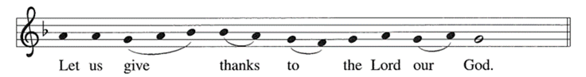
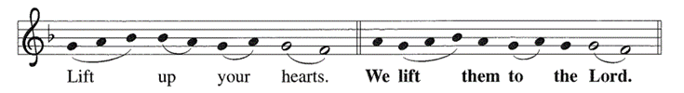
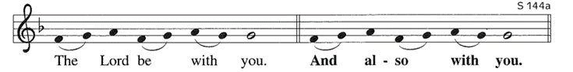

Great Thanksgiving (continued)
P: It is indeed right, our duty and our joy…we praise your name and join their unending hymn…

Holy, Holy, Holy
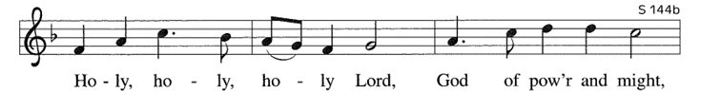
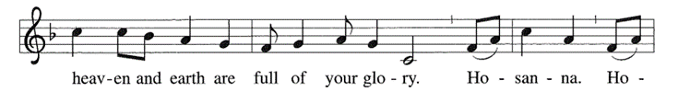
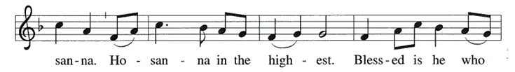
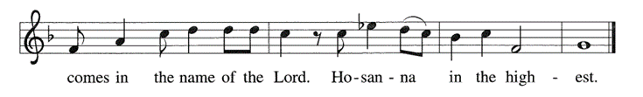

Words of Institution

The Lord’s Prayer

Our Father, who art in heaven, hallowed be thy name,
thy kingdom come, thy will be done, on earth as it is in
heaven. Give us this day our daily bread; and forgive us
our trespasses, as we forgive those who trespass against
us; and lead us not into temptation, but deliver us from
evil. For thine is the kingdom, and the power, and the
glory, forever and ever. Amen.

P: The gifts of God for the people of God. Taste and see that the Lord is good.
**Please note: Gluten-free wafers and white grape juice are available.

Communion Lamb of God
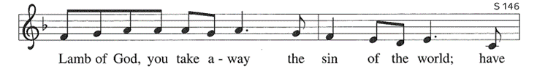
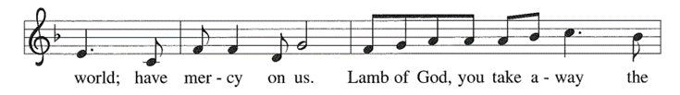
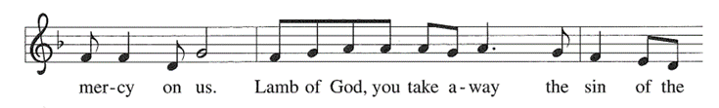
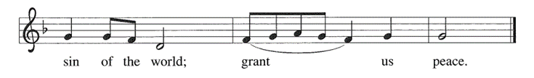
Communion Hymns

O Bread of Life from Heaven ELW 480
Jesus, Still Lead On ELW 624

Post-Communion Blessing

P: The body and blood of our Lord Jesus Christ strengthen you and keep you in his grace. C: Amen.

Post-Communion Canticle

Thankful Hearts
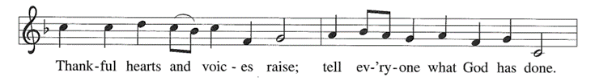
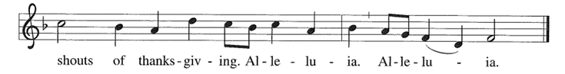
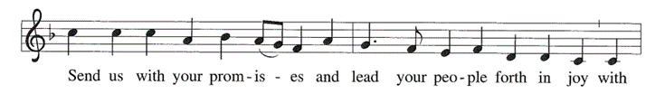
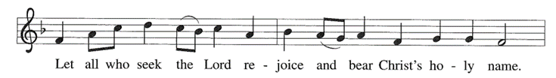
A-a------a----men. A-a-a----a---men
Prayer after Communion

A: Let us pray. God of our salvation, we give you thanks for this meal that restores our souls, reconciles us to you, and strengthens us for the journey.
Through the body and blood of your Son, may we become Christ’s body in the world, bearing witness to your love for all creation, through Jesus Christ, our Savior and Lord.
C: Amen.
SENDING
Blessing

P: Receive the blessing of the holy Trinity: God, who calls all things into existence, Jesus Christ, who redeems us, and the Holy Spirit, whose breath sustains creation, ☩ bless you now and always.
C: Amen.
Sending Song O Jesus, Joy of Loving Hearts ELW 658

Dismissal
A: Go in peace. Believe the good news.
C: Thanks be to God.

*************************************************************************
Please note that Pr. Paul’s devotions in the “A Watered Garden” daily email will be on Wednesday, March 25th. If you have not signed up for the emails, now is the time to do it. See the link on the last page of the bulletin.

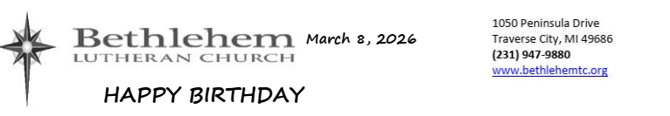

3/08—Corinne Hill 3/12—Tom Christensen
3/10—Gail Tokie 3/15—Jim Boyd
3/11—Laura Acker 3/15—Ann Rundhaug

Worship Servants for March 8
Preaching & Presiding—Pr. Paul Busekist
Assisting Minister—Peggy Burns
Lector—Tim Goebel
Musicians: David Husser, Zeke Clemons, Phil & Denice Bossardet, Pr Paul
Today’s altar flowers are donated: NO ALTAR FLOWERS DURING LENT
Hospitality: Tim & Peggy Goebel
A/V—Jim Hinds / Paul Ton
Cookies/Coffee—Diane Cunningham / Mary Ann Tanis
Welcome Table— Volunteer
Bell Ringer: Tim Goebel
Front Door Monitor—Frank & Pat Wall
Altar Guild—Mary Ann Tanis / Gail Goldsmith
Counters: Laura Hahn / Laura Okimi

FUNDRAISER FOR HABITAT for HUMANITY: Maybe you cannot wield a hammer or travel to a building site, but we all can eat! Culver’s on Munson will donate a portion of all purchases made 5-8pm on March 11. Bring family, friends, and neighbors and help raise funds for Habitat.

March’s XYZ potluck & presentation will be on Friday, March 13th. After a delicious potluck lunch at noon, we will hear a presentation by Kristina Schnepf, the director of Green Door Folk School. Green Door is a recently opened nonprofit that is rooted in the folk school tradition, offering hands-on workshops that connect people to passions, new or old, the land, and each other. Remember, XYZ is predominantly geared toward seniors but the time spent together and the wonderful presentations are enjoyable for adults of any age - we hope you can join us

Verse O.N.T.A.P.: Do you like the Beatles, Pat Benatar, Bob Marley, Elvis (and other artists from the last few decades)? Turns out that scripture has some things to say about love, relationship, and some connections to these rockers’ lyrics! Check out Verse O.N.T.A.P. on Sunday, March 15th - 5:30pm-7:00pm at The Workshop 221 Garland St.

