Twentieth Sunday after Pentecost
October 23, 2022 – 10am
Modern Worship, ELW Setting 3

Prelude Music

Announcements / Temple Talk

Confession and Forgiveness

P: Blessed be the holy Trinity, ☩ one God, who is eager to forgive and who loves us beyond our days.
C: Amen.

P: Dear friends, together let us acknowledge our failure to love this world as Jesus does.

Silence is kept for reflection.

P: God of mercy and forgiveness,
C: …we confess that sin still has a hold on us. We have harmed your good creation. We have failed to do justice,
love kindness, and walk humbly with you. Turn us in a new direction. Show us the path that leads to life. Be our refuge and strength on the journey, through Jesus Christ, our redeemer and friend. Amen

P: Beloved of God: your sins are forgiven ☩ and you are made whole. God points the way to new life in Christ,
who meets us on the road. Journey now in God’s abiding love through the power of the Holy Spirit.
C: Amen.

Gathering Song: Shout for Joy

Pour out your fervent praise; There’s a song to raise like a banner high;
Lift up your grateful heart to the Morning Star; He’s alive and here with us.

Shout for joy, for the Son of God is the Saving One; He’s the Saving One;
Shout for joy, see what love has done; He has come for us; He’s the Saving One.

We stood on sinking sand; He reached out His hand, pulled us to his side;
We turned our hearts away; He was strong to save, now our Savior reigns in us.

Shout for joy, for the Son of God is the Saving One; He’s the Saving One;
Shout for joy, see what love has done; He has come for us; He’s the Saving One.
(interlude)
Oh, oh, oh, oh. Oh, oh, oh, oh.

There is no other God like You; We sing the praises that you’re due Jesus, You have saved us, oh, whoa;
There is no other God who reigns; You are the name above all names; Jesus, You have saved us, whoa, whoa

…and shout for joy, for the Son of God is the Saving One; He’s the Saving One;
Shout for joy, see what love has done; He has come for us; He’s the Saving One.

Greeting

P: The grace of our Lord Jesus Christ, the love of God, and the communion of the Holy Spirit, be with you all!
C: And also with you!

Kyrie

A: In peace, let us pray to the Lord.
C: Lord, have mercy.

A: For the peace from above, and for our salvation, let us pray to the Lord.
C: Lord, have mercy.

A: For the peace of the whole world, for the well-being of the church of God, and for the unity of all, let us pray to the Lord.
C: Lord, have mercy.

A: For this holy house, and for all who offer here their worship and praise, let us pray to the Lord.
C: Lord, have mercy.

A: Help, save, comfort, and defend us, gracious Lord.
C: Amen.

Prayer of the Day

A: Let us pray together
C: Holy God, our righteous judge, daily your mercy surprises us with everlasting forgiveness. Strengthen our hope in you, and grant that all the peoples of the earth may find their glory in you, through Jesus Christ, our Savior and Lord. Amen

Children’s Message Annie Slabaugh

First Reading: Jeremiah 14:7-10, 19-22

In a time of drought, the people pray for mercy, repenting of their sins and the sins of their ancestors. They appeal to God to remember the covenant, to show forth God’s power, and to heal their land by sending life-giving rain.

⁷Although our iniquities testify against us, act, O Lord, for your name’s sake; our apostasies indeed are many,
and we have sinned against you. ⁸O hope of Israel, its savior in time of trouble, why should you be like a stranger in the land, like a traveler turning aside for the night? ⁹Why should you be like someone confused, like a mighty warrior who cannot give help? Yet you, O Lord, are in the midst of us, and we are called by your name; do not forsake us!
¹⁰Thus says the Lord concerning this people: Truly they have loved to wander, they have not restrained their feet;
therefore the Lord does not accept them, now he will remember their iniquity and punish their sins. ¹⁹Have you completely rejected Judah? Does your heart loathe Zion? Why have you struck us down so that there is no healing for us? We look for peace, but find no good; for a time of healing, but there is terror instead. ²⁰We acknowledge our wickedness, O Lord, the iniquity of our ancestors, for we have sinned against you. ²¹Do not spurn us, for your name’s sake; do not dishonor your glorious throne; remember and do not break your covenant with us.

L: The Word of the Lord
C: Thanks be to God

Gospel Acclamation Alleluia

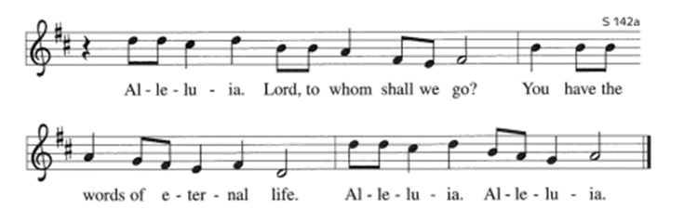

Gospel: Luke 18: 9-14

The coming reign of God will involve unexpected reversals of fortune with judgment rooted in mercy. Jesus tells a parable in which the one who humbles himself is exalted and the one who exalts his own righteousness is humbled.

P: A reading from… C: Glory to You, O Lord.

⁹Jesus also told this parable to some who trusted in themselves that they were righteous and regarded others with contempt: ¹⁰“Two men went up to the temple to pray, one a Pharisee and the other a tax collector. ¹¹The Pharisee, standing by himself, was praying thus, ‘God, I thank you that I am not like other people: thieves, rogues, adulterers, or even like this tax collector. ¹²I fast twice a week; I give a tenth of all my income.’ ¹³But the tax collector, standing far off, would not even look up to heaven, but was beating his breast and saying, ‘God, be merciful to me, a sinner!’ ¹⁴I tell you, this man went down to his home justified rather than the other; for all who exalt themselves will be humbled, but all who humble themselves will be exalted.”

P: The Gospel of the Lord.
C: Praise to you, O Christ.

Sermon Pastor Paul Busekist

Song of the Day: O Jesus, I Have Promised ELW 810

Apostles Creed

I believe in God, the Father almighty, creator of Heaven and earth.

I believe in Jesus Christ, God’s only Son, our Lord, who was conceived by the Holy Spirit, born of the virgin Mary, suffered under Pontius Pilate, was crucified, died, and was buried; he descended to the dead. On the third day he rose again; he ascended into heaven, he is seated at the right hand of the Father, and he will come to judge the living and the dead.

I believe in the Holy Spirit, the holy catholic church, the communion of saints, the forgiveness of sins, the resurrection of the body, and the life everlasting. Amen.

Prayers of the Church / Sign of the Peace

Offering
Offering Song: Change My Heart, O God ELW 801

Offertory: Let the Vineyards Be Fruitful
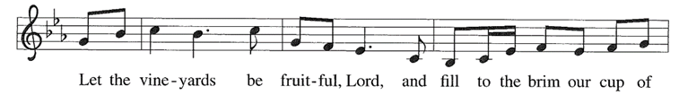

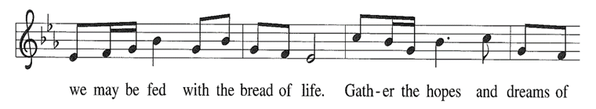
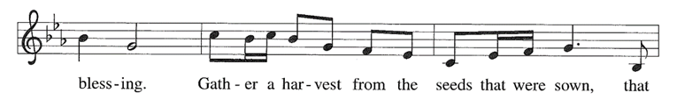

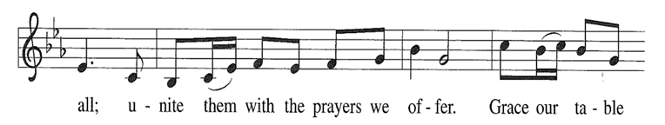

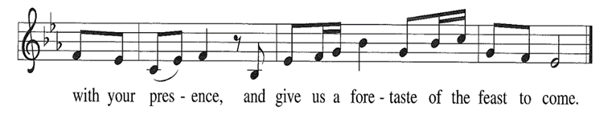

Offering Prayer

A: Let us pray.
C: Gracious God, in your great love you richly provide for our needs. Make of these gifts a banquet of blessing, and make us ready to share with all in need; through Jesus Christ, who sets a table for all. Amen

Words of Institution

Lord’s Prayer

Our Father, who art in heaven, hallowed be thy name, thy kingdom come, thy will be done,
on earth as it is in heaven. Give us this day our daily bread; and forgive us our trespasses,
as we forgive those who trespass against us; and lead us not into temptation, but deliver
us from evil. For thine is the kingdom, and the power, and the glory, forever and ever. Amen.

Communion (Please note: gluten-free wafers and white grape juice cups are available)

Communion Songs: Healer of Our Every Ill ELW 612
Jesus, Keep Me Near the Cross ELW 335

Farewell and Godspeed to Annie, Trent and Caleb Slabaugh

Final Blessing

P: God, who gives life to all things and frees us from despair, bless you with truth and peace. And may the holy Trinity, ☩ one God, guide you always in faith, hope, and love.
C: Amen.

Sending Song: Send Me, Lord (Sung Twice) ELW 809

Dismissal

A: Go in peace, with Christ beside you.
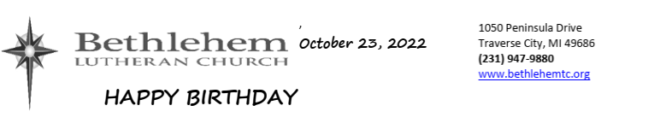
C: Thanks be to God.
10/23—Inge Thomas 10/27—Gerald Hill 10/30—Celia Kane
10/23—Isaac Woolcott 10/29—Nancy Lautner
10/27—Amanda Wegener 10/29—Paul Wiemerslage

Building and Office Hours are: 9:00am – 2:30pm, Monday – Thursday.

Annie and Trent’s Good-bye Celebration: Just a reminder, we will be celebrating Annie, Trent and Caleb’s new adventure today. Annie will be here one more week (this is Trent and Caleb’s last week), but there will be cake, coffee and punch after today’s Worship Service. So please join the Slabaugh family in Fellowship Hall and wish them well.

Giving Statements Available: Your individual giving statements will be available in your mailbox in the Narthex beginning Sunday October 23, 2022. The statement covers giving from January 1st through September 30, 2022. Please pick them up at your convenience. To save on postage, I will mail out the ones not picked up by the end of November 2022. Thank you for your generous support for the programs and ministries of your church. We are all blessed by your faithful giving. Your Bookkeeper

Refresh Committee Update: We are moving along with refreshing the last classroom. We have walls washed and painted and cove base will be installed in the next week. We have replaced all the light fixtures with new LED lights which provides a cleaner light than fluorescent lighting. As we said earlier, there are a few things we needed to replace due to wear, such as a new faucet and some plumbing. We hope to move the books from the office into the new library/conference room by the end of October.
We would also ask if anyone has a Home Carpet Cleaner we could use for a few hours to clean the carpet. If you are able to help please contact Chuck Ardingo, 206-919-7487 or email, dingo457@msn.com

COVID: Please note that masks are required for unvaccinated persons in worship and highly encouraged for those who are vaccinated.

Today’s altar flowers are donated: in Honor of the dedicated prayer warriors of BLC’s prayer chain.

Offerings: The offering plates are now passed during the service. The vase in the back of the Sanctuary is still available for those who prefer not to touch the offering plate.

Third Thursday: The next Third Thursday service will be a Jazz Vespers service on November 17th at 7:00pm. The service will be livestreamed.

BAKE SALE! Christian Education is hosting a bake sale during the craft show on November 5th. In previous years you all have stepped up to share your baking abilities by donating cookies, bars, cakes, pies, lots of goodies! We are asking you again this year to help us out. Please pre-package the cookies and bars in groups of a half dozen and indicate name and ingredients (i.e. chocolate chip with/without nuts, peanut butter, etc). We would also appreciate gluten free treats. Items can be dropped off on Friday during the day or early Saturday morning. Thank You!!

THANK OFFERING SUNDAY COMING UP: Thank Offering Sunday is being held on November 13th. This is the Sunday when most positions of the worship service are handled by women . A special offering will be taken during that service which will be used to support women's ministries churchwide. Thank Offering jars are available in the Narthex; special envelopes will also be provided on November 13th. Please come and join us

The November issue of the STAR is now available. For current issues of the Star, feel free to check online at www.bethlehemtc.org < About Us > “The Online Bethlehem Star” or type this URL to get these directly: http://www.bethlehemtc.org/the-bethlehem-star-newsletter.

Looking for a link to last month’s full Council minutes? Type this address/url into your web browser to get the latest approved minutes from Council: bethlehemtc.org/Council-Minutes OR you may call the office to request a copy.

Prayer Requests:
• Prayer Chain: Please contact Jan Stretlien at jstretlien@gmail.com or 231-947-3265
• Prayers read from the altar: Please call Administrative Assistant in the church office 231-947-9880

Celebrate a new child in your life with a rose on the baptismal font! Cost $10.00 per rose. Contact Barbara Oster at beo6475@yahoo.com or 231.668.7038.

We welcome Julia Acker and family as our new tech support team up in the choir loft.

The newest Living Lutheran magazine and the October/November/December Christ in Our Home can be picked up at the welcome table on Sunday mornings or from the Shooting STAR box below the outside mailbox

Special Book Announcement: Calling all true mystery lovers…we have our own mini-mystery right here at Bethlehem. One of the copies of our most recent book club selection, Isadore’s Secret has not been returned. The library is giving us extra time to attempt to locate it. If you happened to carry it home or saw it in some nook and cranny at church please let the office know.

Coffee and Cookies: You are welcome to stay after the service for coffee, cookies and conversation. This will be done as many Sundays as there are volunteers to make the coffee and/or bring cookies, etc. There is a sign-up sheet available near the cookies. There are open dates, so please sign up!

Name tags: Your name tags are back in your mailboxes. Please walk a little farther and retrieve them so you can proudly wear them on Sunday mornings. We often have visitors and it helps them if they can see a friendly face and attach a name to it.

Choir announcement: The choir will be rehearsing at 7:00pm on Thursday Oct 27th. Please join us! We have a new version of A Mighty Fortress we will be sharing on Oct 30 and it is time to start practicing Christmas music already. Contact Tony Bero at bero.tony@gmail.com or 942-1162.

Adult Bible Study gets together on Wednesdays from 9:00am-11:00am. It is a casual discussion of the Gospel of Mark. Bring your bibles and come, share, learn and grow with us.

The Zoom Bible Study meets on Wednesdays from 1:30pm—3:00pm. We will discuss the Book of Revelation from the Book of Faith. If you are interested, please contact either Pr Paul or Barbara Oster.

You are welcome to attend adult education on Sundays from 9:15am-9:45am in the Youth Room. Discussion will be about the Lessons/Gospel for the day.

Bethlehem's entire congregation now has the opportunity to join the youth in our brand new Intergenerational Events. These are fun opportunities to gather in fellowship with Bethlehem's youth to connect and become a supportive and strong Christian influence. Please contact the church office for more information.

24 hr food pantry closing for the winter: The outdoor pantry will be closing for the winter after the craft show on Nov 6. If you or someone you know needs some extra food please take some before it closes. There will be extra food set out on the day of the show. Before April anyone in need can contact the office to arrange a pick-up from the indoor storage. If you find a deal too good to refuse from Nov to Apr the teal bin will be available below the table by the mailboxes for placing your goodies.

BLC Book Club: The BLC book club’s Oct meeting is on the 25th at 5:30 via ZOOM. The book, The Dutch House, is available in the Book Club box outside of the church. If you are not on the email list and want to be involved send your information to cmonroe@chartermi.net.

LAUNDRY BASKET PROJECT UPDATE: The laundry basket project is ongoing. Please drop off any cleaning items in the Narthex. Families who visit the baby pantry have been most appreciative. Blessings to you all!

Due Dates for STAR/Bulletin/Screen Announcements:
• STAR: The third Friday of the month sent to admin@bethlehemtc.org (Please note STAR in subject line)
• Bulletin/Verbal Announcements: Tuesday of the week sent to admin@bethlehemtc.org (Bulletin/Worship Folder is prepared on Wednesday and printed on Thursday morning.) (Please note Bulletin or Announcement in subject line)
• Screen Announcements/Weekly BLC Emails: Tuesday of the week sent to admin@bethlehemtc.org (Please note Screen Announcements or Weekly BLC Emails in subject line)

Monthly STAR: Thanks to all of you who have said that you will read the STAR on line or pick it up at church. Those of you who come to church, be thinking if there is any member close in your neighborhood that you could deliver their copy to them. If you have recently decided to read on line or pick-up at church please call the office and let them know.

Advent meals are back for 2022! We will be trying Thursday nights this Fall for Advent. The meals are put on by the Fellowship Committee and volunteers. We could really use more volunteers! Is this something that you would be willing to help with, in any capacity that works for you? Do you like to:

*Plan meals
*Shop for food
*Prepare food
*Set up tables and chairs
*Serve food
*Clear tables and put away tables and chairs
*Wash dishes
*Clean up the kitchen after the meal

You don't have to volunteer for ALL of that! If you are able to do just one thing, you are a help and a blessing to everyone who attends and enjoys the Advent Services, including yourself! If this is something you would like to do, or if you have any questions, please contact Laura Hahn at dandlhahn@gmail.com, or 929-1339. Thank you!

Bethlehem Week at Safe Harbor Coming in February: Yes, Bethlehem Lutheran will be joining with Northern Lakes Community Church (a Presbyterian congregation) to provide a week of evening meals again this winter. We will be serving from February 4 through February 10. Bethlehem will take Saturday February 4, Sunday February 5, and Tuesday February 7. “Five Loaves; Two Fish” of Leland is taking February 6- and all Mondays throughout the winter! Northern Lakes will handle the 8, 9, and 10 February. We are coordinating menus as we can to assure variety. Here are a couple other updates:
-I already have the Tina Dohm group committed to February 4th with a lasagna dinner, the Cindy Monroe group signed up for February 5th with a chicken and rice dinner, and the B.J. and Tom Christensen group planning a ham dinner on February 7th.
Come January we will have sheets to sign-up to assist in a number of ways outside of the kitchen with guest interaction and providing breakfast and other items. Reach me at any time at 631-0040. You may have also seen that Safe Harbor is going to be open days on the weekends. Safe Harbor will be looking for volunteers to assist the professional staff with supervision on Saturdays and Sundays during the day. Those shifts will be from 8AM to 1PM and 1PM to 6PM. If you have never volunteered at Safe Harbor before, this could be a good place to start. I can assist you in signing up for one of these opportunities.
Look forward to a regular great response from Bethlehem members. More to come. Mark your calendars! Thank you. Tom Rockne Bethlehem Safe Harbor Coordinator M.231.631.0040

Hoop’s Pet Food Pantry: This is the only pet food pantry in NW lower Michigan. They primarily provide dry food, wet food, treats, cat litter and toys for mostly dogs and cats but they will support any type of pet to the best of their ability. Please visit them at the Square Deal Country Store, 900 Woodmere Ave, TC from 1100am – 2:00pm on the 1st and 3rd Saturday of every month with your donations OR you may leave donations in the tub on our “donations” table next to the mailboxes.

Have something important going on at Bethlehem that you'd like others to know about? Maybe a Small Group? A Club Event? Feature it on the Screen Announcements and on our Facebook Events Page! If there is something you'd like featured or included for either Screen Announcements or Facebook Events please reach out to Annie at annie.slabaugh@bethlehemtc.org.

A big thank you to all who turned in Olesons’ receipts. We received a check from Olesons for $187.74. So far this year we have received a total of $464.62 just for people turning in their Olesons’ receipts. Please continue to drop your Olesons’ receipts off at church.

Please consider signing up for Altar Flowers for a Sunday service. There are plenty of dates available for the rest of the year. You may use the sign-up poster in the Narthex by signing on the date you request. Then fill out a pink slip with the necessary information and place it and a check for $40 (payable to Bethlehem Lutheran Church or BLC) in the offering plate on Sunday morning (Preferable) or during the week, in the Administrative Assistant’s mailbox near the church office entrance. You may select either “in honor” or “in memory” or “to celebrate”. If someone has already signed on the date you would like, feel free to add your name – we welcome more than one on a Sunday.

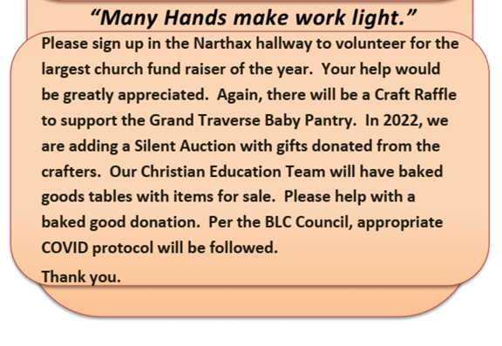

Bethlehem sends weekly emails directly to your inbox with important announcements and information!
If you are not getting them for any reason or if you have something you'd like to have added please reach out to admin@bethlehemtc.org.

The church calendar is below. Please be sure to notify the office (admin@bethlehemtc.org or 231.947.9880) to be sure that your group is on the calendar.

CALENDAR
Sunday, October 23
10:00am—Worship Service (S)
11:00am—Parking Lot Communion
11:15am—Slabaugh Family Farewell Reception (FH)

Tuesday, October 25
Bulletin articles due today
9:00am—LWR Quilters (FH)
9:00am—Property Work Group
10:00am—Staff Meeting (CR)
5:30pm—Book/Supper Club (Zoom)
6:30pm—Newcomers (FH)

Wednesday, October 26
9:00am—Adult Bible Study
11:30am—Music Rehearsal (S)
1:00pm—Johnson SG (Offsite)
1:30pm—Zoom Bible Study

Thursday, October 27
5:30pm—ACOA (FH)
7:00pm—Choir Rehearsal (S)

Saturday, October 29
9:00am—All Star DE (FH)

Sunday, October 30
10:00am—Worship Service (S)
10:00am—Confirmation of Julia Acker and Jacob Graf
11:15am—Reception for Confirmands

