Reformation Sunday
October 31, 2021 – 10am
Modern Worship, ELW Setting 4

Prelude Music

Announcements

Confession and Forgiveness

P: Blessed be the holy Trinity, ☩ one God, whose teaching is life, whose presence is sure, and whose love is endless.
C: Amen.

P: Let us confess our sins to the one who welcomes us with an open heart.

Silence is kept for reflection.

P: God our comforter:
C: …like lost sheep, we have gone astray. We gaze upon abundance and see scarcity. We turn our faces away from injustice and oppression. We exploit the earth with our apathy and greed. Free us from our sin, gracious God.
Listen when we call out to you for help. Lead us by your love to love our neighbors as ourselves. Amen.

P: All have sinned and fall short of the glory of God. By the gift of grace in ☩ Christ Jesus, God makes you righteous.
Receive with glad hearts the forgiveness of all your sins.
C: Amen.

Gathering Song: A Mighty Fortress ELW 504

A mighty fortress is our God, a sword and shield victorious; he breaks the cruel oppressor’s rod and wins salvation glorious.

The old satanic foe has sworn to work us woe! With craft and dreadful might he arms himself to fight. On earth he has no equal.

No strength of ours can match his might! We would be lost, rejected. But now a champion comes to fight, whom God himself elected.

You ask who this may be? The Lord of hosts is he! Christ Jesus, mighty Lord, God’s only son adored. He holds the field victorious.

Though hordes of devils fill the land all threat’ning to devour us, we tremble not, unmoved we stand; they cannot overpow’r us.

Let this world’s tyrant rage; in battle we’ll engage! His might is doomed to fail; God’s judgment must prevail! One little word subdues him.

God’s Word forever shall abide, no thanks to foes, who fear it; for God himself fights by our side with weapons of the Spirit.

Were they to take our house, goods, honor, child, or spouse, though life be wrenched away, they cannot win the day. The kingdom’s ours forever!

Greeting

P: The grace of our Lord Jesus Christ, the love of God, and the communion of the Holy Spirit, be with you all!
C: And also with you!

Kyrie

A: In peace, let us pray to the Lord. C: Lord, have mercy.
A: For the peace from above, and for our salvation, let us pray to the Lord. C: Lord, have mercy.
A: For the peace of the whole world, for the well-being of the church of God, and for the unity of all, let us pray to the Lord. C: Lord have mercy.
A: For this holy house, and for all who offer here their worship and praise, let us pray to the Lord.
C: Lord have mercy.
A: Help, save, comfort, and defend us, gracious Lord. C: Amen.

Prayer of the Day

A: Let us pray together,
C: Almighty God, gracious Lord, we thank you that your Holy Spirit renews the church in every age. Pour out your Holy Spirit on your faithful people. Keep them steadfast in your word, protect and comfort them in times of trial, defend them against all enemies of the gospel, and bestow on the church your saving peace, through Jesus Christ, our Savior and Lord, who lives and reigns with you and the Holy Spirit, one God, now and forever.
Amen.

Children’s Message

Temple Talk – Time & Talents

First Reading: Jeremiah 31:31-34

The renewed covenant will not be breakable, but like the old covenant it will expect the people to live upright lives. To know the Lord means that one will defend the cause of the poor and needy (Jer. 22:16). The renewed covenant is possible only because the Lord will forgive iniquity and not remember sin. Our hope lies in a God who forgets.

³¹The days are surely coming, says the Lord, when I will make a new covenant with the house of Israel and the house of Judah. ³²It will not be like the covenant that I made with their ancestors when I took them by the hand to bring them out of the land of Egypt—a covenant that they broke, though I was their husband, says the Lord. ³³But this is the covenant that I will make with the house of Israel after those days, says the Lord: I will put my law within them, and I will write it on their hearts; and I will be their God, and they shall be my people. ³⁴No longer shall they teach one another, or say to each other, “Know the Lord,” for they shall all know me, from the least of them to the greatest, says the Lord; for I will forgive their iniquity, and remember their sin no more.

L: The Word of the Lord
C: Thanks be to God

Gospel Acclamation: Alleluia ELW Page 151

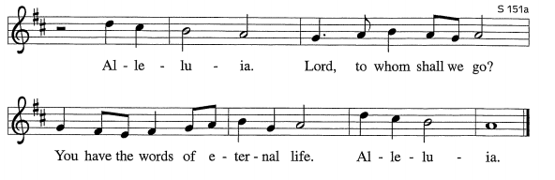

Gospel: John 8:31-36

Jesus speaks of truth and freedom as spiritual realities known through his word. He reveals the truth that sets people free from sin.

P: A reading from… C: Glory to You, O Lord.

³¹Jesus said to the Jews who had believed in him, “If you continue in my word, you are truly my disciples; ³²and you will know the truth, and the truth will make you free.” ³³They answered him, “We are descendants of Abraham and have never been slaves to anyone. What do you mean by saying, ‘You will be made free’?”
³⁴Jesus answered them, “Very truly, I tell you, everyone who commits sin is a slave to sin. ³⁵The slave does not have a permanent place in the household; the son has a place there forever. ³⁶So if the Son makes you free, you will be free indeed.”
P: The Gospel of the Lord.
C: Praise to you, O Christ.

Sermon – Pastor Paul

Song of the Day: The Church’s One Foundation ELW 654

Recognition of New Members: John & Marilyn Halstead

Reception of New Members

P: Dear friends, we give thanks for the gift of baptism and for our new friends in Christ, one with us in the body of Christ, whom we welcome as new members into the life of this congregation:

A representative of the congregation introduces the new member/s:

We welcome John and Marilyn Halstead to the family, mission & ministry of Christ at Bethlehem.

Address and Questions to New Members

P: In baptism, we are welcomed into the body of Christ and sent to share in the mission of God. We are called to live among God’s faithful people, to hear the word of God and share in the Lord’s supper, to proclaim the good news of God through word and deed, to serve all people, following the example of Jesus, and to strive for justice and peace in all the earth.

P: John and Marilyn, our brother and sister in Christ, do you intend to continue in the covenant of your baptism among God’s people in this place?

Those being welcomed respond: I do, and I ask God to help and guide me.

P: (The minister addresses the assembly) People of God, do you promise to support and pray for these new members in their life in Christ?

C: We do, and we ask God to help and guide us.

Those being welcomed face the assembly. The pastor addresses all.

P: Let us welcome John & Marilyn to this community of faith:

C: We rejoice with you in the life of baptism. Together we will give thanks and praise to God and proclaim the good news to all the world.

Apostles Creed

I believe in God, the Father almighty, creator of Heaven and earth.

I believe in Jesus Christ, God’s only Son, our Lord, who was conceived by the Holy Spirit, born of the virgin Mary, suffered under Pontius Pilate, was crucified, died, and was buried; he descended to the dead. On the third day he rose again; he ascended into heaven, he is seated at the right hand of the Father, and he will come to judge the living and the dead.

I believe in the Holy Spirit, the holy catholic church, the communion of saints, the forgiveness of sins, the resurrection of the body, and the life everlasting. Amen.

Prayers of the Church/Sign of the Peace

Offering (encouraged for before or after service, using vase only and not ushers)

Offering Prayer

A: Let us pray.
C: God of abundance, you cause streams to break forth in the desert and manna to rain from the heavens.
Accept the gifts you have first given us. Unite them with the offering of our lives to nourish the world you love so dearly; through Jesus Christ, our Savior and Lord. Amen.
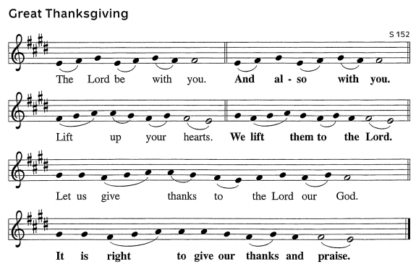
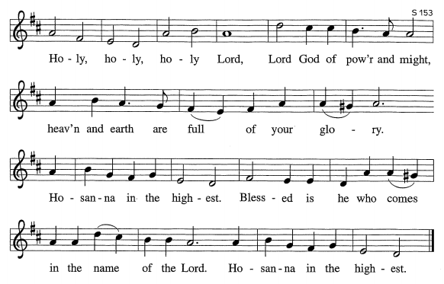

Words of Institution

Lord’s Prayer

Our Father, who art in heaven, hallowed be thy name, thy kingdom come, thy will be done,
on earth as it is in heaven. Give us this day our daily bread; and forgive us our trespasses,
as we forgive those who trespass against us; and lead us not into temptation, but deliver
us from evil. For thine is the kingdom, and the power, and the glory, forever and ever. Amen.
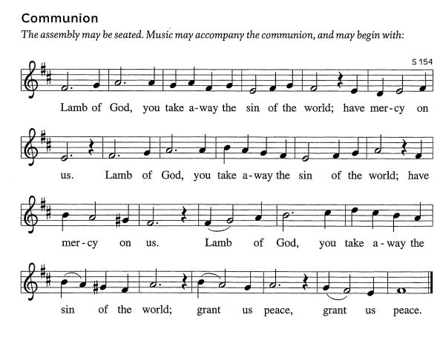

Communion

Communion Songs:
Break Now the Bread of Life ELW 515
Amazing Grace ELW 779

Final Blessing

P: People of God, you are Christ’s body, bringing new life to a suffering world. The holy Trinity, ☩ one God,
bless you now and forever.
C: Amen.

Sending Song: Soul on Fire (words below)

God, I’m running for Your heart, I’m running for Your heart ‘til I am a soul on fire.
Lord, I’m longing for Your ways. I’m waiting for the day when I am a soul on fire, ‘til I am a soul on fire.
God, I’m running for Your heart, I’m running for Your heart ‘til I am a soul on fire.
Lord, I’m longing for Your ways. I’m waiting for the day when I am a soul on fire, ‘til I am a soul on fire.
Lord, restore the joy I had. I have wandered, bring me back.
In this darkness, lead me through until all I see is You, yeah!
God, I’m running for Your heart, I’m running for Your heart ‘til I am a soul on fire.
Lord, I’m longing for Your ways. I’m waiting for the day when I am a soul on fire, ‘til I am a soul on fire.
Lord, let me burn for You again. Let me return to You again.
And Lord, let me burn for You again! And let me return to You again!
God, I’m running for Your heart, I’m running for Your heart ‘til I am a soul on fire.
Lord, I’m longing for Your ways; I’m waiting for the day when I am a soul on fire,
God, I’m running for Your heart, I’m running for Your heart ‘til I am a soul on fire.
…’til I am a soul on fire, ‘til I am a soul on fi—re.

Dismissal

A: Go in peace. The living Word dwells in you.
C: Thanks be to God.

